Mental State Transfer
Author: Ben
Version: v0.14
Date: 06/01/2023
This document sets out the principles, order of authority and rules of the commune. Subject to change by the author. All new members must agree to this document before taking part in the commune.

0) Definitions

0.1) Commune
The commune where the members live and socialise, this can either be a physical location or an online meeting place. The commune will most likely be a charity, community interest company or church for tax and legal reasons.
Size: 1-Unlimited
Location: Undecided
Leader: Author
Ideology: Narco-Communism

0.2) Member
A member of the commune, to become a member you must read and agree to this document, fore fill any conditions set by the leader, then ask the leader to become a member. Membership does not come with any guarantees and may be revoked by the leader at any time.

0.3) Leader
The leader of the commune, this a position with a lot of responsibility and power. The leader is expected to always be fair [1.1] and not to abuse the power [2.1 and 2.2].

0.4) Roles
Roles can be assigned by the leader in order to delegate some power and responsibility to antoher member, this can be revoked at any time by the leader.

0.5) Communal ownership
All property in the community is communally owned and freely accessible to all members in the commune (with the exception of punishment in case of someone deliberately wasting community resources). The leader (or treasurer) is ultimately responsible for the allocation of resources.

0.6) Initial contribution
This is a means tested contribution that all members (including the leader) are expected to make towards the running costs of the commune (i.e. food, substances, bills). Members are expected to take out a loan (details to be ratified) and donate it all to the commune. This is by default a non refundable donation to a charitable organisation. Which will use this donation only for the good of the community, and not for anything that would only benefit some members.

0.7) Law
The leader (and this document) is the highest form of law in the commune, it overrules any existing laws of the land or acts of government. As [1.1] states, the leaders say is final (unless the leader changes their mind).

0.8) Relations with other States/Communes
The leader (or member in communications role) is responsible for any negotiations with other communes/states. The commune can negotiate and buy/sell (import/export) as a whole unlike individual members, this is because the commune can not produce everything it needs (for example electricity and food). Exports are unlikely at this stage because money for imports is coming from new members donations.
Picture to demonstate the flow of resources:
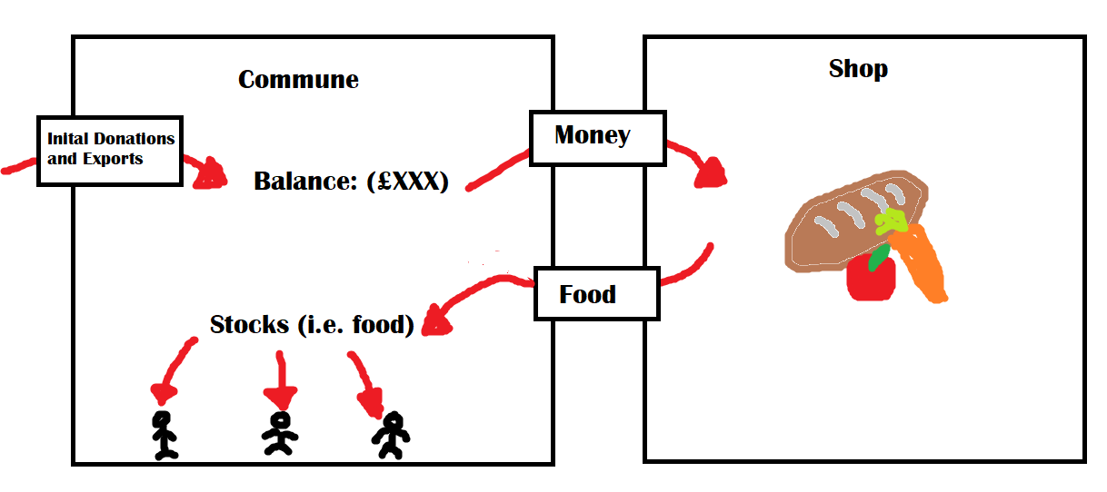

0.9) Freedom of Association
This is a voluntary commune, nobody is forcing you to participate. You cant receive the benefits of living in the commune without following its rules and principles. If you don’t want to live in the commune then that is fine, but don’t expect anything free without putting in the required ammount of work.

1) Authority

1.1) Final say
The leader has the final say on all issues, though will always be fair and follow the principles

1.2) Assigned roles
The leader can delegate roles and powers to other members of the commune to allow everything to run smoothly. For example security may be delegated to another member of the commune, this will allow them to be the authority on security matters. However 1.1 still applies and the leader has the final say.

2) Principles

2.1) Absolute equality
Absolute equality of outcome in all situations, except in very specific situations (for example you wouldn’t give everyone in the society a wheelchair when they don’t need one).

2.2) No special treatment
No privilege or extra benefits will ever be given to anyone (especially not for people in a position of power).

2.3) Everyone gets one chance to change
With the exception of murder, rape, and treason. This especially applies to when someone disagrees with the progress, they should always be given a chance to change their ways/views.

2.4) Common Sense applies
Everyone is expected to have some common sense, if they really don’t have it then they can be taught.

2.5.1) Right to freedom of Speech
With the exception of for example shouting “fire” in a crowded building and causing a stampede. If your speech doesn’t harm or affect other members of the commune then it should be allowed, common sense applies (rule 2.4).

2.5.2) Freedom of Religion
Everyone has the right to practice their own religion (within reason, no human or animal sacrafices). As long as your religion doesn’t affect others you have the right to freely practice and worship.

2.6) Open and transparent society
Everyone is expected to be open and transparent, this means most crimes can be prevented or the culprits caught far quicker. If you don’t want to be included as a suspect for a crime then you should have your phone on (this is yet to be implemented). All logs and information is by default public, if you have any concerns speak to the leader.

2.7) Right to Fun
Everyone (over 16) has the right to access any substance without the fear of persecution. The only time you need to be reasonably free of intoxication is when operating machinery or in a situation where you being high could endanger others,

2.8) No Money or Private Property
Everything is free and communally owned, personal property for example toothbrushes and clothes are allowed.

3) Jobs, Responsibilities and Expectations

3.1) Everyone must Contribute
Everyone is required to work an equal amount of days if they are able. The number of work days and work hours are set by the state and apply to everyone. Hard manual jobs have regular breaks to make sure its fair.

3.2.1) Jobs are Assigned
Which job/jobs you do is fairly assigned, and people are expected too share their expertise so that if there is an accident there is someone else able to fill their role.

3.2.2) Work Days/Hours
The goal ammount of work everyone will do is 2 full days, this may fluctuate in order to make sure that everything is able to be produced, or imported. Ideally it should not exceed 3 full days.

3.3) Live for the Commune
We are expected to live and fight for the good and security of the commune, this includes stuff cleaning up after yourself to resisting police aggression. We cant just let the commune fall because of a technicality.

3.4) Clean up after Yourself
All members are expected to leave everything as they found it, to use all resources responsibly. Nothing must be left overnight except with direct permission of the leader.

3.5) Be Nice
No being a dick to anyone else, everyone in the community is like minded and expected to get on with each other.

3.6) No runs on shops
Just because everything is free doesn’t mean take as much as you can. Take only as much as you need, so if your old tv is broken to the point where you cant watch it then you can take one, but don’t go take one just because.

4) Justice

4.1) No Police/non-commune authority
No calling the ”police”/”authorities”, except in the case of a super serious crime (such as murder or rape). In all cases where possible use the communes dispute resolution, this is in order to

4.2) Dispute Resolution
This goes back to 1.1, the leader (or member with delegated authority) can give out punishments as they see fit, this includes:
- Verbal warning
- Revocation of privileges
- Expulsion from the commune (may be with or without starting contribution)

4.3) No prisons
No wasting time and money looking after people who have committed horrible crimes, instead either re-education or execution for the most serious crimes.

5) Scenarios

5.1) Eating
You may eat whatever there is available, however you are expected to only cook what you will eat and to be mindful of waste. Wash up immediately or as soon as possible for larger meals. Put away everything as soon as it is washed and dry (should not be more than a few minutes after you are finished eating)

5.2) Films, Netflix and Music
What music, movie or show should be a community decision, if you really have a problem with the community choice you can always leave the communal area.

5.3) Home Invasion
In a situation where the community is threatened, all members of the community are expected to help defend. The first action is to make contact and negotiate, this is undertaken by the leader or head of security. If the negotiation fails then defensive countermeasures are turned on (strobe lights, door bolts). If these fail then all members should defend the commune at all costs.

